# (1) Overview

## Title

Compact four-channel syringe pump with radial distribution

## Paper authors

1. Cano-Ferrer, Xavier

2. Konstantinou, George

3. Dix, Christina

4. Jones, David

5. Treeck, Moritz

6. Imbert, Albane

## Paper author roles and affiliations

1. Francis Crick Institute, Making Science and Technology Platform, London NW1 1AT, UK

2. Francis Crick Institute, Making Science and Technology Platform, London NW1 1AT, UK

3. Francis Crick Institute, Making Science and Technology Platform, London NW1 1AT, UK

4. Francis Crick Institute, Signalling in Apicomplexan Parasites Laboratory, London NW1 1AT, UK

5. Francis Crick Institute, Signalling in Apicomplexan Parasites Laboratory, London NW1 1AT, UK

6. Francis Crick Institute, Making Science and Technology Platform, London NW1 1AT, UK

## Abstract

In science experimental setups specially in microfluidics and organ on a chip is commonly required to precisely control the flow rate under certain conditions or dispense small volumes controlled by a computer. Syringe pumps are often a reliable solution for such goals. In this paper we present a novel design to use for experiments when the same flow rate is required for experiments were different conditions with the same flow rate are required. We show the design we propose archives both good accuracy and repeatability in a wide range of flow rates and very small error between each one of the four syringes due to its radial distribution. Finally, the present work can be manufactured by using 3D printed parts or the combination of 3D printing and laser cutting.

|  |
| --- |
| Metadata Overview Main design files: https://github.com/FrancisCrickInstitute/Four_channel_syringe_pump  Target group: Microfluidics, biomedical sciences, chemistry  Skills required: 3D printing – easy; laser cutting – easy; through hole soldering - easy; mechanical assembly – intermediate  *See section “Build Details” for more detail.* Keywords microfluidics; multi-syringe pump; flow control; volume dispensing |

## Introduction

Biomedical science experiments very often require parallelise multiple biological conditions with the same flow rate [References]. Syringe pumps are a commonly used tool to precisely control flow rate in scientific experiments. Over the last decade, several research labs, individual researchers or even makers have developed rapid manufactured syringe pumps. Over the last decade, several research labs, individual researchers or even makers have developed rapid manufactured syringe pumps. This list includes the model from the from the Janelia research campus (Karpova, 2017), Jakob Voigts design (Voigts, 2019), the Poseidon syringe pump system developed on California Institute of Technology (Booeshaghi *et al.*, 2019), the Open-source syringe pump from the Michigan Tech's Open Sustainability Technology Lab (Wijnen *et al.*, 2014), the 3D Printed Syringe Pump Rack by Aldric Negrier (Negrier, 2015) or the DIY Syringe Pump by David Florian (Florian, 2018).

All previously mentioned designs actuate a single syringe and therefore, they don’t allow to have multiple syringes actuated by the same motor in a small footprint. The cost of the commercial options can vary within a huge range of options in dual syringe pumps, from a dual syringe pump AL2-220 (996 GBP) to a SP200iZ (6,230 GBP) syringes with a dispensing accuracy of ±1\%. In this paper we present a low cost (~ 183 GBP) design that actuates four 10 mL syringes by the dame actuator with a small footprint (24 x 14 x 8 cm), which can be easily embedded inside an experimental environment (microscope chamber or incubator). Our device also provides open hardware software and hardware making it easily adapted to custom user needs. Finally, our syringe pump takes the advantage of using the highly reliable and precise stepper motor control provided by the teensystep.h library (Niggl, 2017) to achieve high performance device.

## Overall Implementation and Design

### System Architecture

The four-way syringe pump is physically composed by a board that controls a stepper motor angular position or velocity. The stepper motor’s shaft is mechanically coupled with a lead screw-rail linear system, which moves a car where the syringe plungers are attached all within a compact footprint (Figure 1a). The flow rate can be manually selected using a rotary encoder and visualized on an OLED screen (Figure 1b). There are two limit switches that stop the pump from moving outside its range.

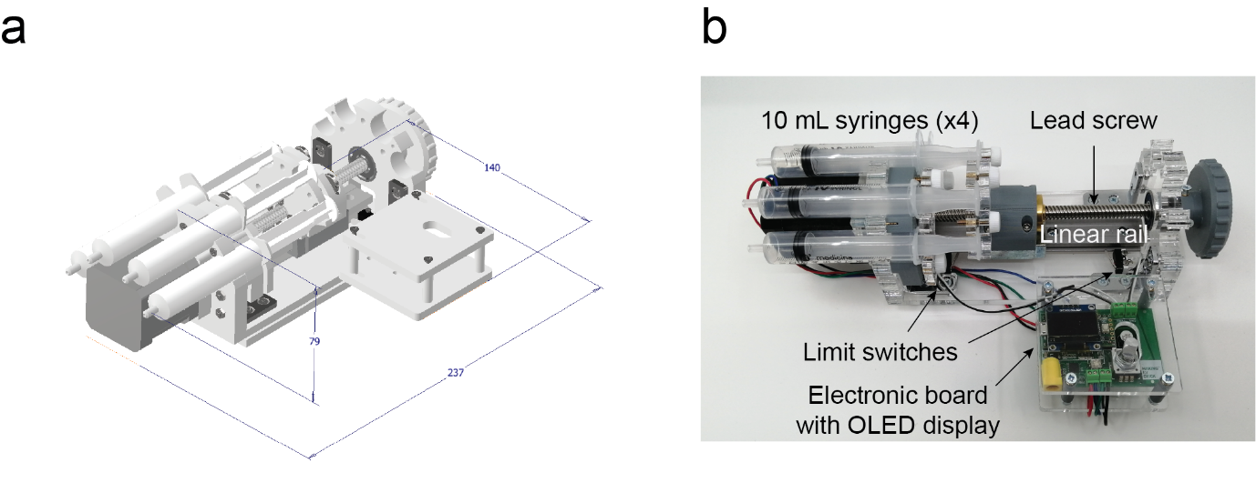

Figure 1: Device overview a. Device dimensions b. Device completely manufactured.

### Electronics

The pump has a main board based on the Teensy 3.2 development board (Freescale Semiconductor MK20DX256). The flow rate can be selected rotating the mechanical incremental encoder (Bourns PEC11R). The rotary encoder can be pressed to change the pump state to active. When this happens, the pump will start dispensing the fluid at the previously selected flow rate. The OLED display (SSD1306 128x64 Pixels) constantly shows the flow rate selected and the volume and flow rate that are being dispensed. The stepper motor is controlled by a Micro-stepping Driver A4988 (Allegro MicroSystems LLC) with five selectable step modes: full step, 1/2, 1/4, 1/8, 1/16. There are two connections for limit switches (Youmile micro switch) which provide safe end stops in both ends of the pump’s linear rail.

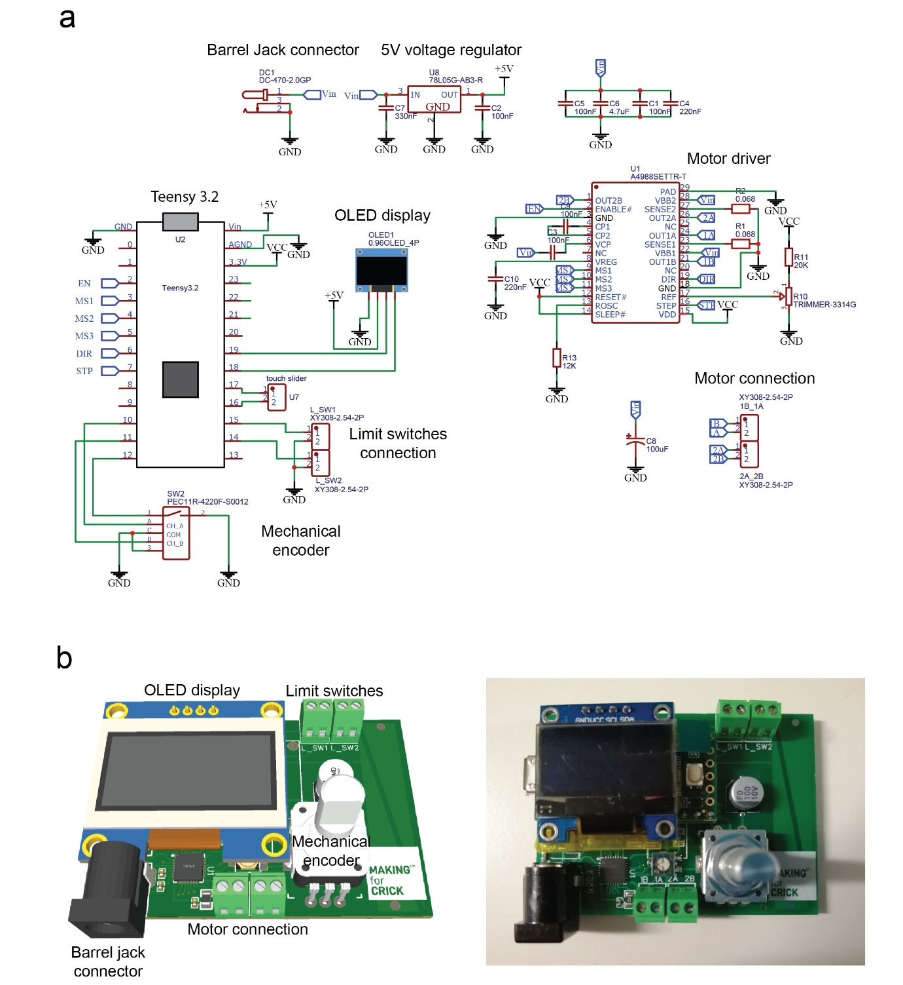

Figure 2: Electronics. a. Electronics Schematics b. PCB CAD model and main connections (Left) and manufactured board (Right).

### Mechanical parts

The device is actuated by a stepper motor (JoyNano Nema 17 1.7 A 59 N·cm) which is coupled with a lead screw (COEUGE T8 20 cm) across a linear rail system (Igus TS-04-15-300). The pump construction is based mostly on parts that can be manufactured by a standard laser cutter and four components which are 3D printed. In that way the device can be manufactured in a single day. The materials used are Polymethylmethacrylate (PMMA) for the laser cut parts and Polylactic Acid (PLA) for the 3D printed parts. Stainless-steel brackets hold the main structure in place giving rigidity to the syringe holders (Figure 3).

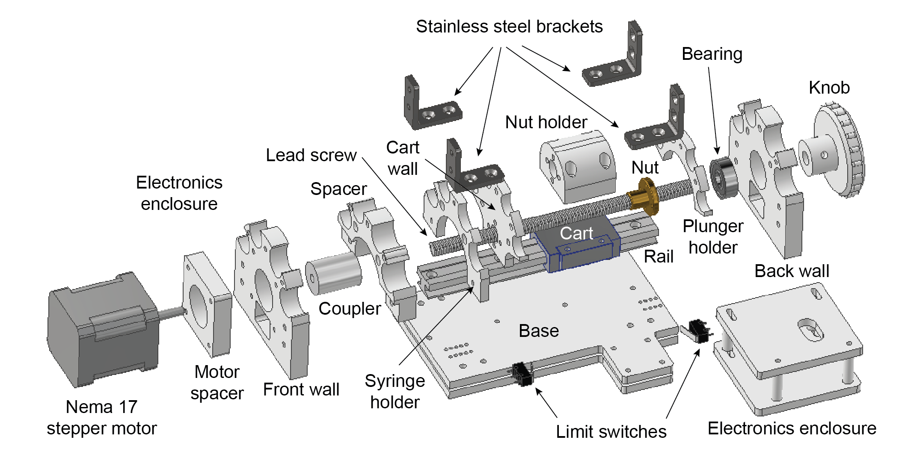

Figure 3: Exploded view of the main mechanical parts, screws are not considered on this figure.

### Firmware

The program running inside the pump (MSTPump_Contstant_flow.ino) has a boolean variable state set to low. The power from the motor is disabled initially, that is achieved by pulling high the enable pin of the driver. The state variable can change only if the encoder pushbutton is pressed. If both limit switches and the state variable are pulled high, the motor power will be enabled and the motor speed will be set at the associated flow rate selected by the user. The flow rate selected can be changed while the motor is engaged but it will not be made effective until the state goes from low to high again. The flow rate in µL·min-1 and the volume in µL are displayed in the OLED screen.

# (2) Quality control

## Safety

The device is operated at 12 V DC, some precautions when handling fluids around the pump must be taken to avoid harming the circuitry. There is also a risk of fingers pinged or trapped with an element of the mechanical system.

## Validation and testing

The calibration procedure of the pump has been carried on by gravimetric testing. An analytical scale (Sartorius TE124S) has been used to weight five labeled Eppendorf tubes. Then the same scale has been used to measure each of the repetitions for all dispensed volume (10-1000 µL) and flow rate (100-10,000 µL·min-1) conditions. After all the measurements, the weight of the corresponding Eppendorf tube has been subtracted from the measurement leaving only the weight of water. Between experiments, the tubes have been dried out completely making sure any drops of fluid were left. A total of five readings have been taken for each experiment condition.

The resolution expressed in minimum volume that can be dispensed using the 8 mm lead screw is 437.5 nL. If needed this can be reduced by changing the lead screw, there are options which range from 1 to 8 mm leads. The firmware has three constants that can be adapted if a physical characteristic of the pump is adapted, they are the number of steps per revolution (3200 steps), the lead size (8 mm) and the syringe area (175). These three parameters are included in the volumetric resolution.

The volumetric resolution () is calculated as the minimum volume that can be delivered with a certain lead (), syringe cross sectional area () and stepping resolution ().

The speeds in the stepper control library are in steps per second therefore, flow-rate resolution is calculated just with the product:

There are two functions which are called when volume or flow-rate need to be converted in steps or steps per second:

The function which returns the number of steps () by a given volume () in µL:

The function which returns the number of steps per second () by a given flow rate () in µL/min:

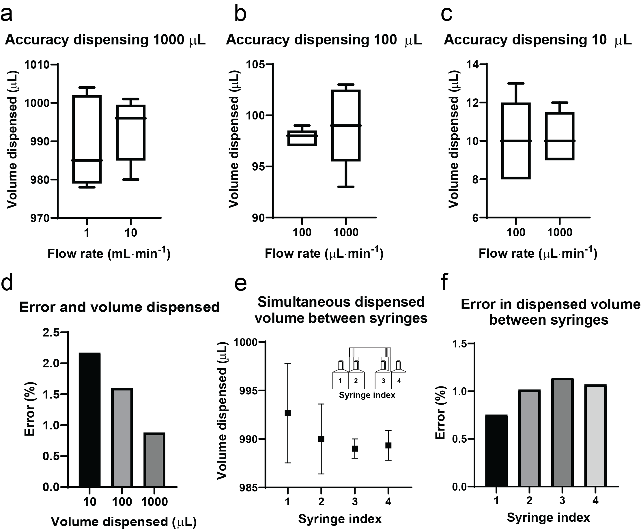

Figure 4: Pump repeatability. a. Accuracy dispensing 1 mL at 1 and 10 mL·min-1. b. Accuracy dispensing 100 µL at 100 and 1,000 µL·min-1. c. Accuracy dispensing 10 µL at 100 and 1,000 µL·min-1. d. Relationship between error and volume dispensed. e. Average, maximum and minimum volume values when dispensing 1000 µL between syringes. f. Error in dispensed volume between syringes. Specify error bars.

# (3) Application

## Use case(s)

Concentration gradient generation in a tree-shape microfluidic device

The first use case provided is an example using the load cell simultaneously with the encoder in the rotary encoder configuration to acquire angular velocity and force at the same time in a unilateral row with a conical/inertial pulley (Figure 5a). The encoder is set up in rotational mode and coupled with the inertial pulley shaft (RSP conic). This case shows the importance of simultaneous acquisition of speed and force data.

### Experiment with multiple experimental conditions at the same flow rate (Colaboration)

The device can provide a clear picture of the data that cannot be measured in any other way such as dynamic exercises performed using rigid devices, for instance suspension training devices where the force is usually unknown because it is applied against a rigid strap. Figure 5b shows the force over time of eccentric and concentric contractions, which can be clearly identified in the hip extension full cycle. The plotted signals are an average of three repetitions per leg.

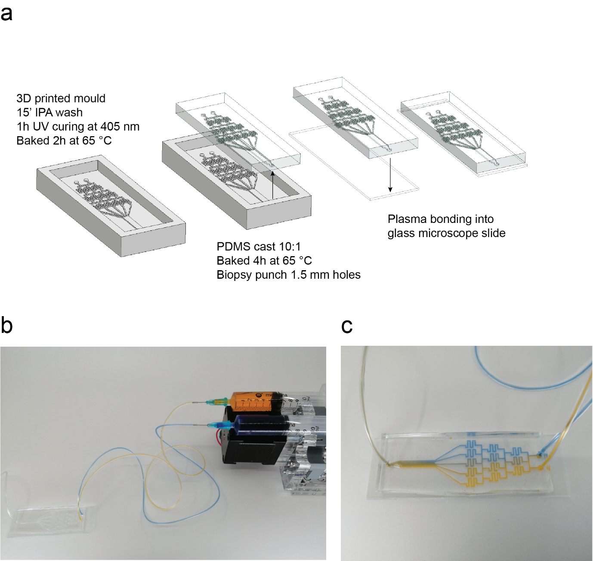

## Reuse potential and adaptability

In the way the manufacturing is proposed, the main components such as the Teensy 3.2 and the Adafruit TFT display can be reused for other devices or for future versions of the Sport Analyzer, reducing the components needed for future versions as they are attached using pin headers. The modularity of the sensor connection ensures that the sensors can be connected to future devices.

# (4) Build Details

## Availability of materials and methods

Summarise what materials have been used to construct the hardware and what methods to process the materials as well as the assembly. Provide more details or references where important materials or methods are non-standard, not globally available or produced only by one manufacturer.

The complete [bill of materials](https://github.com/XaviCanoFerrer/Sport_Analyzer/tree/main/Bill/%20of/%20Materials) can be found on the Sport Analyzer repository as well as the detailed [assembly instructions](https://github.com/XaviCanoFerrer/Sport_Analyzer/tree/main/Assembly/%20instructions). All the electronic components are widely available, and the device has been designed to be easily reproduced, simple to use and customize, durable and robust.

## Ease of build

All the electronic components are soldered on the PCB without the need of stripping or crimping any wire and providing a more robust and durable design. Some of the electronic components are surface-mount technology (SMT) components and therefore the use of tweezers to hold them when soldering is recommended. The mechanical components have been designed to be manufactured with any technique: the three case components and the encoder base are 2D designs with a certain height which can be achieved laser cutting acrylic of different thicknesses or with any 3D printer (Figure 6).

Figure 6: Manufacturing process workflow diagram.

## Operating software and peripherals

The firmware is uploaded on the Teensy 3.2 development board using the Arduino IDE and their add-on Teensyduino developed by PJRC. It can be found on the “Firmware” folder of the main [repository](https://github.com/XaviCanoFerrer/Sport_Analyzer/tree/main/Firmware/Sport_Analayzer_1.0).

## Hardware documentation and files location:

***Archive for hardware documentation, modifiable design files, software and build files.***

**Name:** GitHub

**Persistent identifier:** <https://github.com/XaviCanoFerrer/Sport_Analyzer>

**License:** GPL-3.0 License

**Date published:** 25/02/2022

**Publisher:** Xavier Cano-Ferrer

# (5) Discussion

## Conclusions

This article introduces the design of an open-source device which allows monitoring and recording of two of the most important variables to measure patient’s health in physiotherapy and athlete’s performance. It introduces the sport science and rehabilitation professional communities into the world of making, understanding, and customizing their own measuring hardware devices. The device also opens the perspective of hacking the existing strength and resistance training equipment to attach the sensors described and record or visualize the variables of interest. In summary, Sport Analyzer can help a wide variety of professionals to collect data for their scientific studies and their daily athlete/patient monitoring by being able to extract mechanical impulse, mechanical work, muscle concentric and eccentric contraction power, maximum voluntary contraction (MVC) in isometric muscle contractions, angular and linear velocities, among others.

## Future Work

The next future improvement that is currently taking place is adapting the platform to the newest Teensy version, the Teensy 4.0, which is currently under testing. We are also working on a version compatible with the existing Chronojump hardware and software. Joining forces with Chronojump ensures the availability and improvement of the device with future improvements under the same open source license. Some of the future improvements we are currently working on are: Menu, vertical axis auto-scaling, files organized in folders, during the capture the device will show the name of the subject, the capability to detect changes from concentric to eccentric movements, set the zero in inertial machines, display real time power by multiplying force and velocity, tared force for exercises where a limb weight is involved but it does not have to be measured, the possibility to add a force goal which is displayed on the screen as a horizontal line and be able to import or export data to the Chronojump software.

## Paper author contributions

X.C-F. conceived the presented idea, designed the hardware, wrote the firmware and analyzed the data. X.P-C. contributed to the firmware and hardware. X.C-F., X.P-C., J.M.P-R., X.D.B.F. acquired the data, discussed the results and contributed to the final manuscript.

## Acknowledgements

We thank Pau Gómez, Pier Setti, Artur López and Rainiero Avero for the feedback of the functionality of the device based on their extensive professional experience in sport science and coaching. We want to acknowledge Sandra Segura-Bayona for the feedback provided on the manuscript writing.

## Competing interests

The authors declare that they have no competing interests.

## References

Booeshaghi, A. *et al.* (2019) ‘Principles of open source bioinstrumentation applied to the poseidon syringe pump system’, *Scientific reports*, 9(1), pp. 1–8.

Florian, D. (2018) *Syringe Pump*. Available at: https://www.drdflo.com/pages/Projects/Syringe-Pump.html.

Fredericks, T. O. (2013) *Debouncing library for Arduino and Wiring*, *2013*. Available at: https://github.com/thomasfredericks/Bounce2.

Karpova, A. (2017) *Karpova lab syringe pump*. Available at: https://karpova-lab.github.io/syringe-pump/.

Kasprzak, K. (2020) *Functions to draw graphs on LCD*. Available at: https://github.com/KrisKasprzak/GraphingFunction/blob/master/Graph.ino.

van Loenen, J. (2016) *Image2cpp*. Available at: http://javl.github.io/image2cpp/.

Necula, B. (2014) *An Arduino library to interface the Avia Semiconductor HX711 24-Bit Analog-to-Digital Converter (ADC) for Weight Scales*. Available at: https://github.com/bogde/HX711.

Negrier, A. (2015) *3D Printed Syringe Pump Rack*. Available at: https://www.instructables.com/3D-Printed-Syringe-Pump-Rack/.

Niggl, L. (2017) *TeensyStep: Fast Stepper Motor Library for Teensy boards*. Available at: https://luni64.github.io/TeensyStep/.

Stoffregen, P. (2014a) *Optimized ILI9341 TFT Library*. Available at: https://github.com/PaulStoffregen/ILI9341_t3/graphs/contributors.

Stoffregen, P. (2014b) *SD library*. Available at: https://github.com/PaulStoffregen/SD.

Stoffregen, P. (2014c) *SPI library for Teensy & Arduino IDE*. Available at: https://github.com/PaulStoffregen/SPI.

Stoffregen, P. (2015) *Quadrature Encoder Library for Arduino*. Available at: https://github.com/PaulStoffregen/Encoder.

Voigts, J. (2019) *Low cost laser cut syringe pump*. Available at: http://jvoigts.scripts.mit.edu/blog/low-cost-syringe-pump/.

Wijnen, B. *et al.* (2014) ‘Open-source syringe pump library’, *PloS one*, 9(9), p. e107216.

# Copyright notice

Authors who publish with this journal agree to the following terms:

Authors retain copyright and grant the journal right of first publication with the work simultaneously licensed under a [Creative Commons Attribution License](http://creativecommons.org/licenses/by/3.0/) that allows others to share the work with an acknowledgement of the work's authorship and initial publication in this journal.

Authors are able to enter into separate, additional contractual arrangements for the non-exclusive distribution of the journal's published version of the work (e.g., post it to an institutional repository or publish it in a book), with an acknowledgement of its initial publication in this journal.

By submitting this paper you agree to the terms of this Copyright Notice, which will apply to this submission if and when it is published by this journal.